**Assessment Cover Sheet**

**Student Name: Joel Martin, Jose Ravida, Kaylee Fatchen**

**Student ID: a240087, a240102, a240044**

|  |  |
| --- | --- |
| **Unit Name:** | Game Development Project 2 |
| **Unit Code:** | GDC 100B |
| **Lecturer Name:** | Harry Eason |
| **Assessment Title:** | Agile documentation |
| **Due Date:** | 02/09/2024 |
| **Page Count:** | 17 |

**Student Declaration:**

I understand that:

* I declare that all material in this assessment is my own work except where there is clear acknowledgement and reference to the work of others.
* This original work adheres to assessment criteria including group assessment.
* Penalties apply for late submission of assessment and that this could result in a failure grade being awarded.

Student Signature: Joel M., Jose Ravida, Kaylee Fatchen Date: 02/09/2024

|  |
| --- |
| FREAKY ISOPODS |
| GAME DESIGN DOCUMENT |
|  |

|  |
| --- |
| FREAKY ISOPODS |
| GAME DESIGN DOCUMENT |

# Document Version History

|  |  |  |  |
| --- | --- | --- | --- |
| Version | Author | Date | Comment |
| 1.0 | Joel M. | 30/07/24 | Created document |
| 1.1 | Jose R., Kaylee F. | 13/08/24 | Added elevator pitch |
| 1.2 | Jose R. | 19/08/24 | Completed Overview segment |
| 1.3 | Jose R. | 27/08/24 | Added Level concepts and descriptions. |
| 1.4 | Kaylee F. | 29/08/24 | Added Descriptions to Narrative and Art sections |
| 1.5 | Kaylee F. | 1/09/24 | Added Images to Creature, Levels and Art Sections |
| 1.6 | Kaylee F. | 1/09/24 | Updated Contents page |
| 1.7 | Joel M. | 2/09/24 | Re-formatting |
| 1.8 | Joel M. | 2/09/24 | Rewrote Mechanics, Loops |

# Contents

Summary 3

Elevator Pitch 3

Hook 3

Overview 3

Narrative 4

Setting 4

Mechanics 5

Loops 6

Art 7

Predators 8

Levels 10

Mood Boards 11

# Summary

|  |  |
| --- | --- |
| Title | Freaky Isopods |
| Genre | Auto-runner, auxiliary game |
| Platform | Windows |
| Controls | Keyboard, Gamepad |
| Software | Unity, Maya, Substance Painter |
| Programming Languages | C#, HLSL |
| Visuals | Tamagotchi, Low-poly, Y2K |

|  |  |
| --- | --- |
| Elevator Pitch | Hook |
| Rush back to the deep ocean as you are hunted by predators, avoiding them by overcoming obstacles in ways they cannot. | “Roll into a game involving cute isopods and prehistoric creatures. Make split-second decisions and evade predators through obstacles in a time of ancient animals.” |
|  |  |

# Overview

*Freaky Isopods* is an auto-runner puzzle game. Players assume the role of a prehistoric isopod that must overcome the hostile flora and fauna of the era. Solve a series of elaborate real-time puzzles that test problem-solving skills, strategic thinking, and adaptability, a reflection of the challenges faced by early life forms in those dynamic ancient environments.

# Narrative

The isopod colonies are scattered, strewn across a prehistoric landscape. The isopods long for a return to the sea. As the player, you control these forlorn isopods, evading predators while finding your way back to the deep sea. You and your critter friends traverse distinct environments that bring you further into the ocean, eventually establishing a new super-colony.

# Setting

The world has devolved back into a Palaeozoic era, where flora and fauna dominate and massive creatures roam round, towering the environment. the atmosphere holds remnants of the modern world, featuring plants and animals which have devolved back into dinosaurs, The isopods however, remain durable, and have kept their colony thriving, but as large predators begin to invade, the isopods are compelled to disperse from their colony and retreat to the deep ocean, As the player, you will lead your pack through various landscapes, encountering different creatures along the way

# Mechanics

The player moves forward automatically and has 6 movement options available to them.

**Four Speeds:** Slow, Medium, Fast, and Stop **Avoidance Options:** Jump, Burrow

**Life System:** The player controls a chain of isopods, which represents the number of chances they get in a level. Players will intuit this mechanic when they lose an isopod for the first time.

If the player fails to avoid an obstacle, or a predator follows them through three consecutive obstacles, the predator eats the last isopod in the chain.

**Checkpoints:** When reaching a checkpoint, refill the isopod chain. If the isopod chain is full, reward player with an extra isopod. This is similar to the Super Mario Bros. power up system. A Power-Up block always gives a Mushroom, unless the player already has a Mushroom then it gives a Fire Flower.

**Obstacle Variety:** Isopod cannot go through stone, only dirt. If the player tries to go through or burrow through stone, it counts as an obstacle fail.

**Enemy Variety:** Different predators can follow the player through different obstacle types. If the player jumps over an obstacle and is being chased by a Veloci-Fly, then the Veloci-Fly will continue following the player.

**Controls**: S/↓ Slow, D/→ Medium, W/↑ Fast, A/← Stop

# Loops

|  |
| --- |
|  |
| The moment-to-moment gameplay loop |

**Win Conditions:**

|  |  |  |
| --- | --- | --- |
| **Overall** | **Compulsion** | **Moment-to-moment** |
| Make it to the end of the game. | Make it to the next level. | Make it to the next checkpoint. |

**Lose condition**: If predators eat all the isopods, the player restarts from the last checkpoint.

# Art

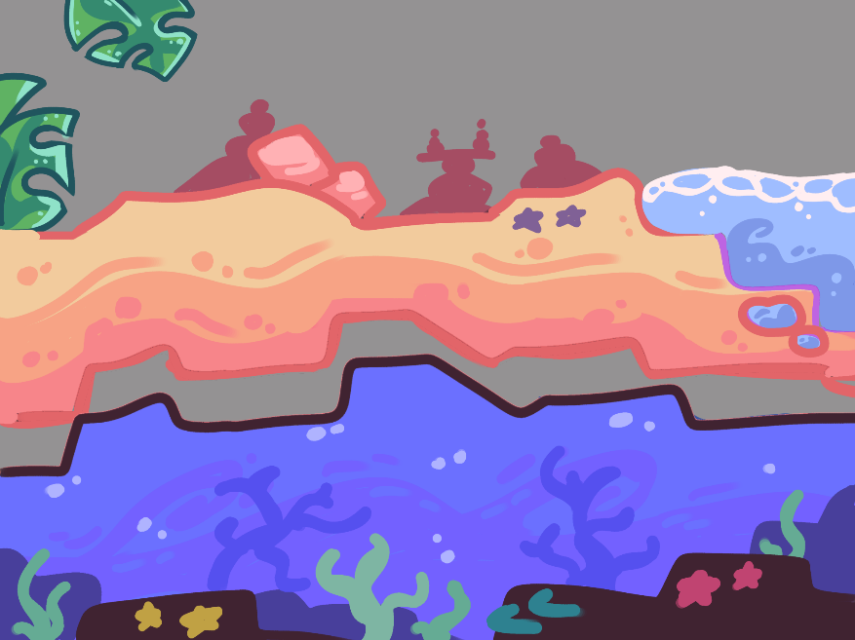Freaky Isopods will have a colourful 2D art style consistent in backgrounds, landscapes, and textures. The environment will be brightly appealing between the land and sea, with levels filled with exotic plants and corals.   
  
Each level will be viewed from a 2D perspective, the image below is a painted example of this, however, the environments will be replicated in a 3D space. Bold saturated colours will be painted for each asset to captivate players towards the visually aesthetic appearance and bring a joyful energy to the game.

# Predators

|  |  |
| --- | --- |
|  | **Gallo-dactylus** is a species of large chicken-like dinosaurs with small heads and large feathers, which assist in gaining speed while running. They are of medium size and can be found scavenging above shallow waters as with scaley subspecies living among the coastal areas |
|  | **Veloci-Fly** closely resembles a dragonfly-like insect with a long body, large eyes and sharp pincered- appendages. This predator evolved to live in the shallow waters of the reefs, can traverse between the land and aquatic levels. as well as its sub species of wasp hybrids, staying among the sandy dunes of the coastal area |
|  | **The** **Leviadon** is a large, paddle-appendaged apex predator, found in the deep sea. Protruding from its back are a plated set of back fins. This creature also features a spade tale and an elastic jaw. It can only be found in the deep-sea areas of the game. |

# Enemies & Obstacles

The enemies featured in *Freaky Isopods* will be the predators that will be looking to hunt down the player’s isopod colony. These will be unique creatures based on real animals with a fantastical prehistoric twist. These predators will be appropriately selected for the game’s coast, reef and deep ocean biomes.

The various vegetation will act as obstacles to the isopods as they flee from the predator. These will correspond to the biomes the levels are set in.

# Levels

In *Freaky Isopods*, there are three distinct areas with their own enemies, terrain and obstacles. The game chronicles the adventures of the isopods as they go deeper into the marine environment of the Palaeozoic-like world of *Freaky Isopods*.

The coasts are the first and easiest area of the game, with more land-based dinosaurs serving as the main enemies for the isopods. As this will be the introductory period for the player, there will be a lack of obstacles and more beneficial terrain. This area houses sand dunes and large rocky sections where scaley and bug-like creatures' roam around. The isopods will need to seek shelter amongst the sand or enter the water to avoid predators.

The reefs serve as the second area and thus will present a more difficult challenge. The terrain features densely coral vegetated and complex topography associated with reef biomes. Corresponding with this increase in traversal difficulty, the aquatic creatures serve as more difficult predators in this region, camouflaging amongst the deep blues and complimentary reds of the coral reefs.

The third location found in the game, providing the highest level of difficulty is the deep ocean. This increase in difficulty made possible through both the deep ocean vegetation and predators. These predators being paddle-appendaged and can glide through waters faster than the isopods. Although these other components have become more difficult, the terrain is relatively simpler compared to the reefs. This easier traversal is supplemented by a unique to this area feature – darkness – that will make it harder to see oncoming obstacles or chasing predators.

# Mood Boards

|  |
| --- |
|  |
| Mood board for the coast levels of Freaky Isopods |
|  |
| Mood board for the deep ocean levels of Freaky Isopods |